Step 1:

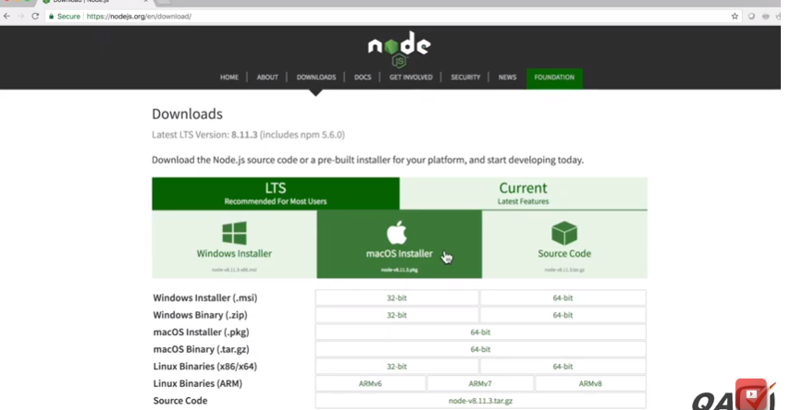

Install npm and check it’s version

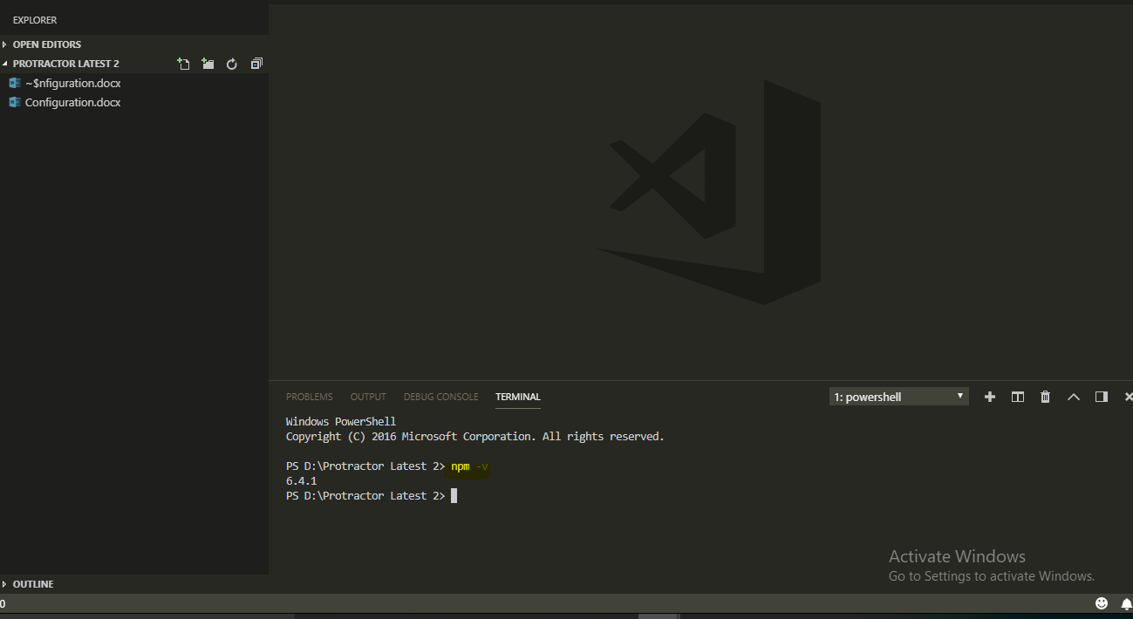

Purpose of ‘npm’ is to install other node packages such as ‘protractor’

Step 2: Install protractor

$npm init

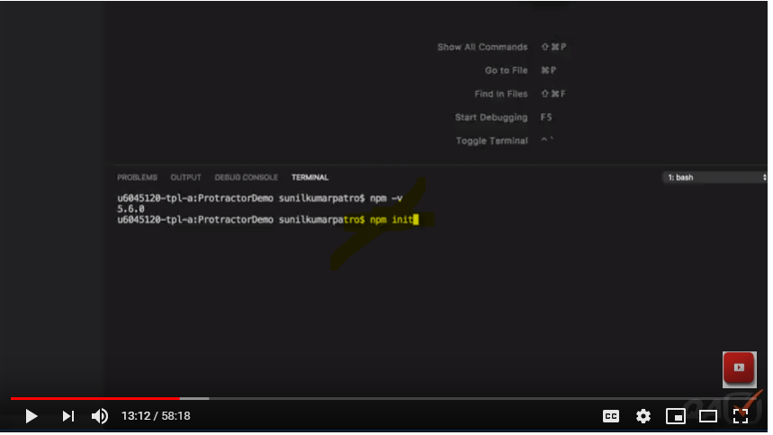

It will create the ‘package.json’ file

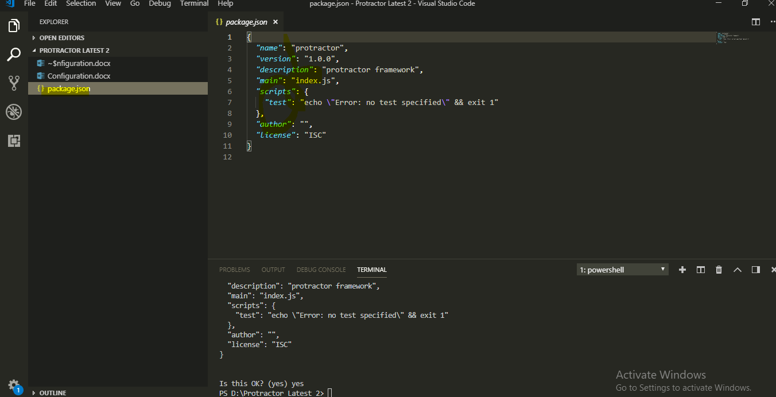

Actually **package.json** acts as a maven pom.xml where dependencies are mentioned and by using those dependencies, the respective tools/or libraries can be downloaded.

Step 2.1 – Install jasmine. Jasmine can be installed through jasmine as follow:

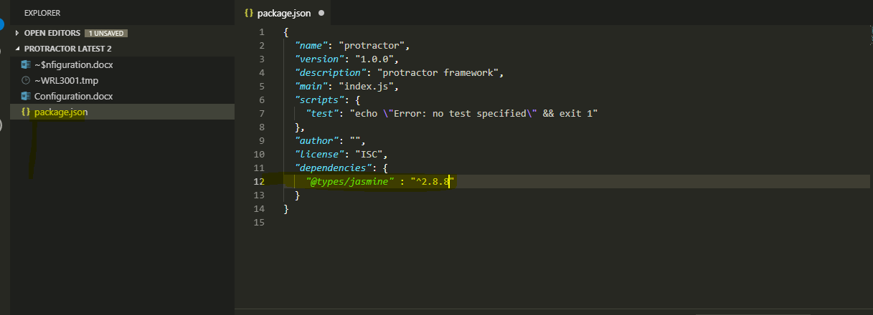

Or we can install directly by following the following command

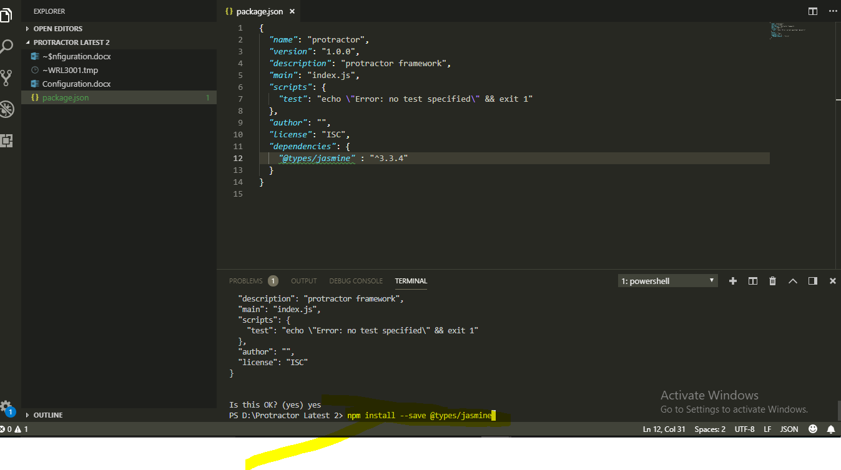

Step 3: Install protractor and typescript and jasmine as follow:

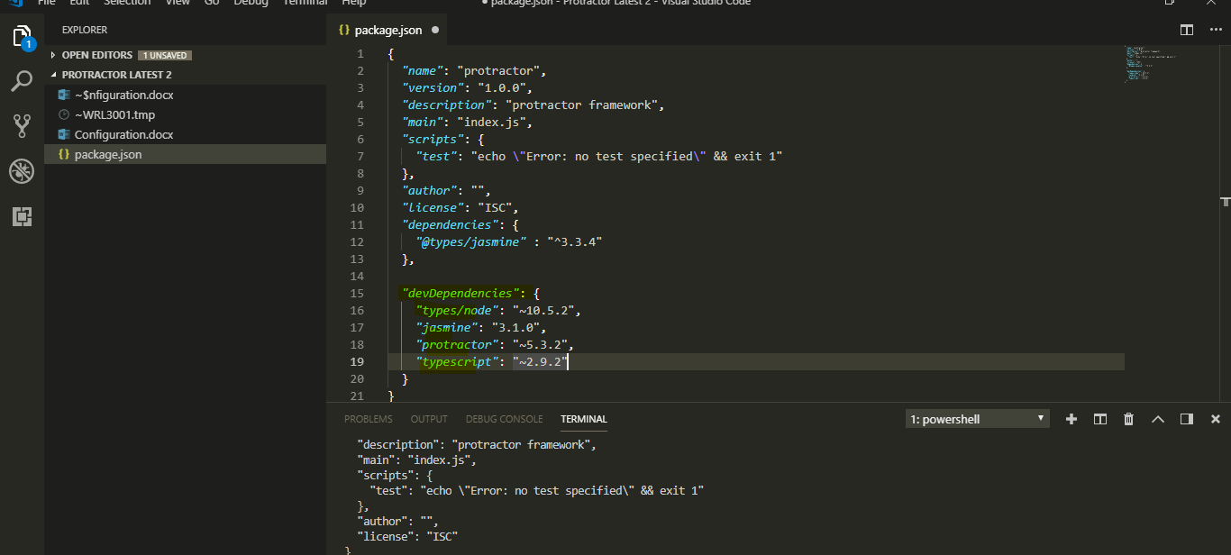

Step 4: Define “tsc”, “pretest” and “test” as follow

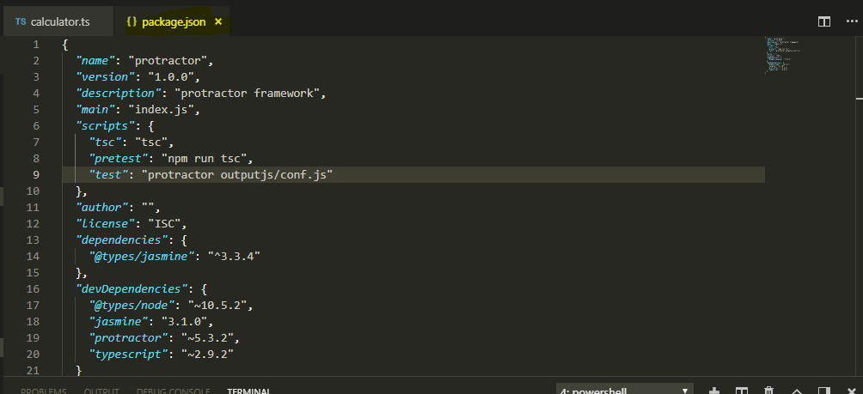

Step 5: Now issue “npm install” command. It will install all the dependencies

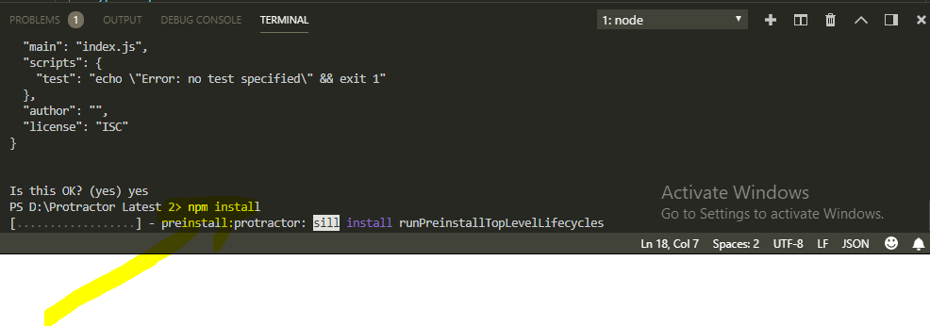

After the installation, one ‘node_modules’ folder will be created as follow and under this folder there is “webdriver-manager”, “protractor” and “typescript”

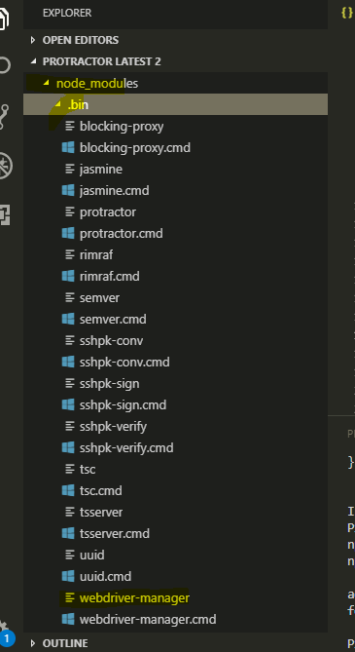

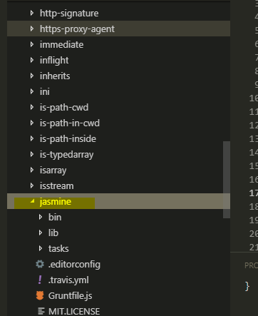

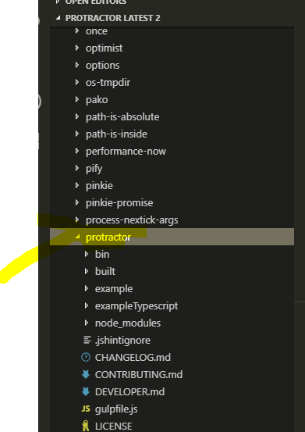

Step 6: Now create “tsconfig.json” file by issuing the following command

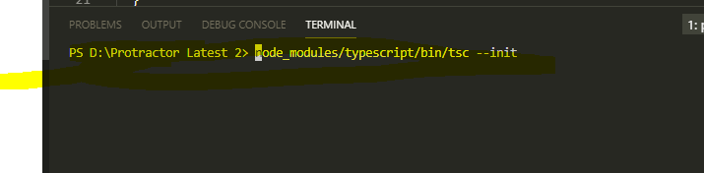

If any case, we cannot create the above file, then manually create it by pasting the following contents for tsconfig.json” should be as follow:

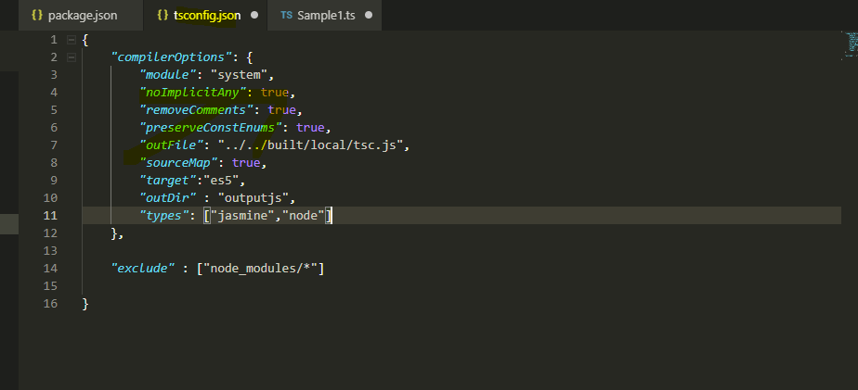

Step 7: Create a new .ts file

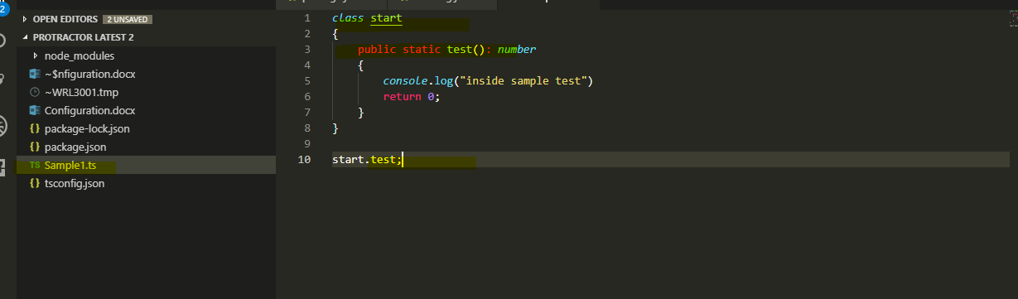

Step 8: Now run the following ‘tsc’ command to convert above file to .js file because browser understands only java script (.js) but not the .ts (type script) file.

$tsc Sample1.ts

Note: This command will only if type is installed globally with the following command

$npm install –g typescript

After running the above command, an equivalent java script will be created as follow:

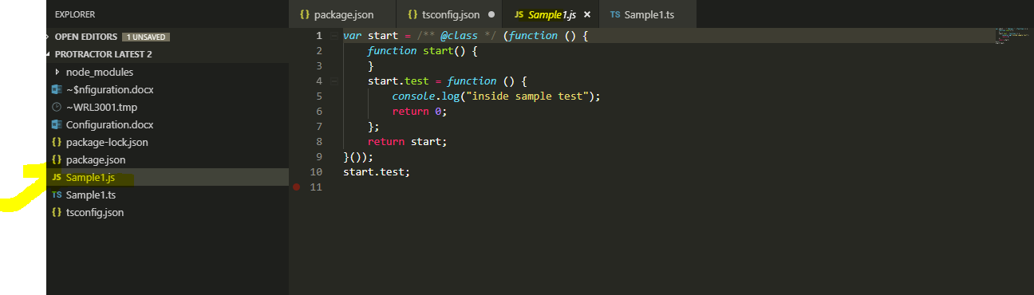

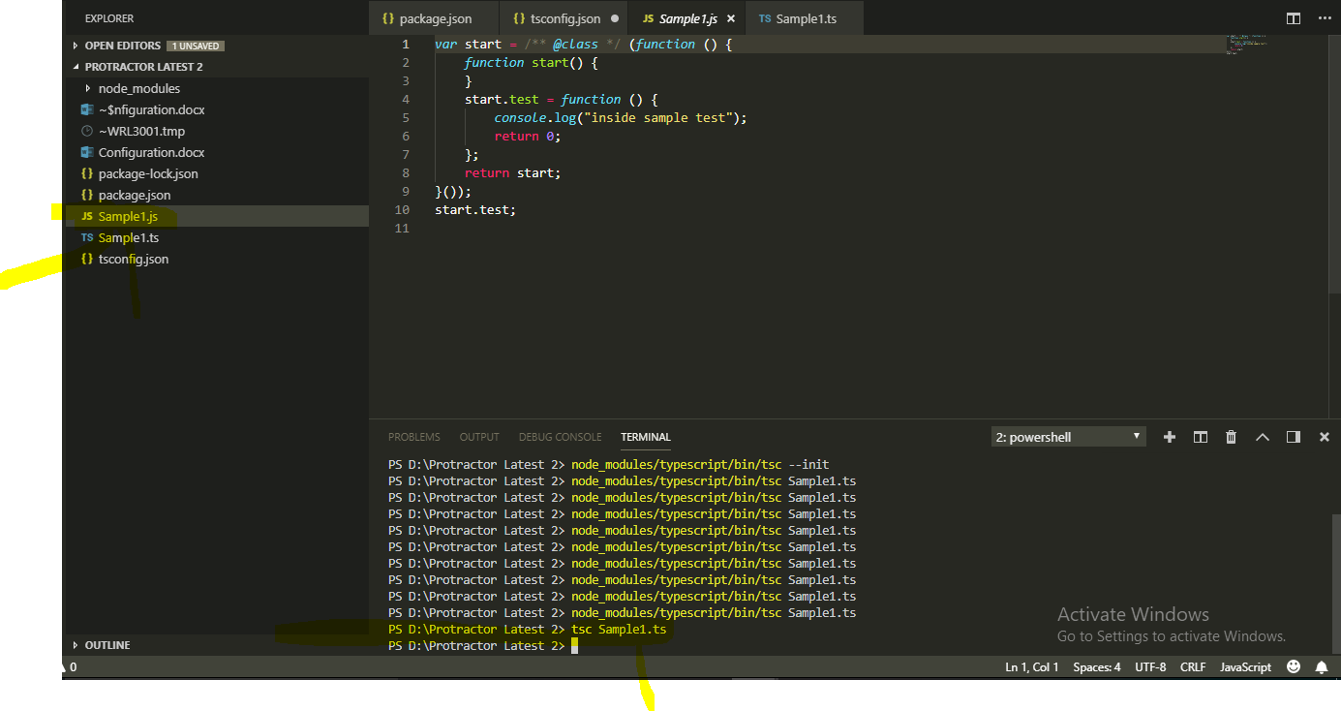

**Configuration & creation of first Protractor script:**

**Step 1: First create a conf.ts file as follow:**

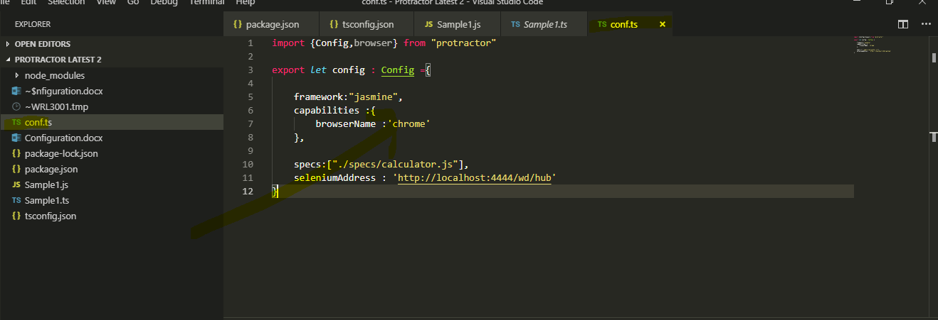

import {Config,browser} from "protractor"

export *let* config : Config ={

framework:"jasmine",

capabilities :{

browserName :'chrome'

},

specs:["./specs/calculator.js"],

seleniumAddress : 'http://localhost:4444/wd/hub'

}

**Step 2: Now create a script or specs**

**First create a .ts file such as calculator.ts file as follow:**

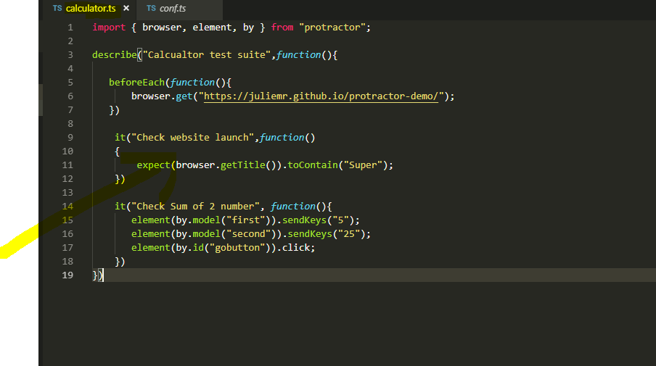

**But before running the above we have to start the web driver server. Even before starting the web driver server we have to update the web driver files.**

**Now run the web driver update command as follow;**

**Since webdriver server resides under bin folder of node module so navigate to node module and issue the following command to update the web driver**

Issue: Sometimes, system throws a following issue while updating the ‘webdriver-manager update’.

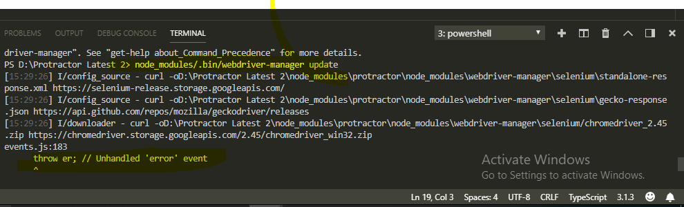

Solution: This issue arises when connected to VPN. Disconnect from vpn then it will resolve the issue.

After disconnecting the vpn:

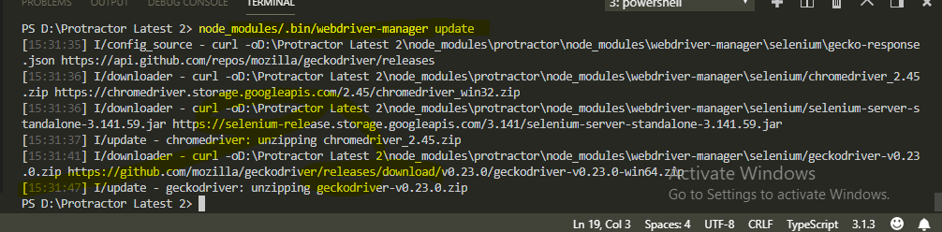

Now start the webdriver manager to start the webdriver start as follow:

$ node_modules/.bin/webdriver-manager start. (Note: Don’t forget ‘.’ Before the bin folder)

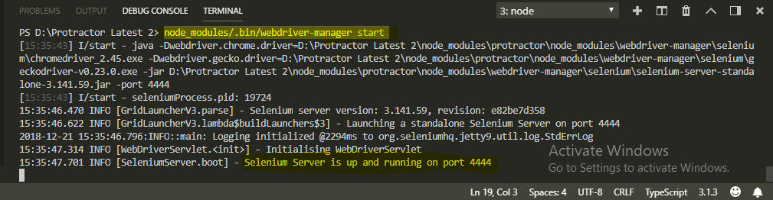

Now execute the protractor test by using the following command

$npm test

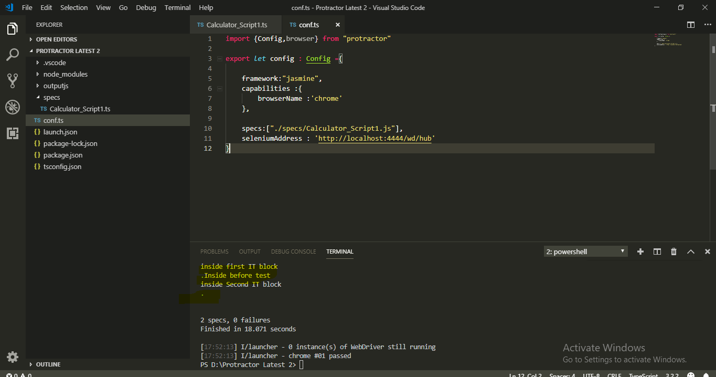

So below should be the contents of all the basic configuration, if something above goes wrong.

1. Package.json

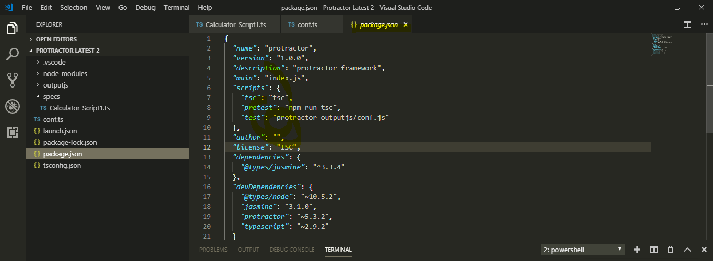

{

*"name"*: "protractor",

*"version"*: "1.0.0",

*"description"*: "protractor framework",

*"main"*: "index.js",

*"scripts"*: {

*"tsc"*: "tsc",

*"pretest"*: "npm run tsc",

*"test"*: "protractor outputjs/conf.js"

},

*"author"*: "",

*"license"*: "ISC",

*"dependencies"*: {

*"@types/jasmine"*: "^3.3.4"

},

*"devDependencies"*: {

*"@types/node"*: "~10.5.2",

*"jasmine"*: "3.1.0",

*"protractor"*: "~5.3.2",

*"typescript"*: "~2.9.2"

}

}

1. Config.ts

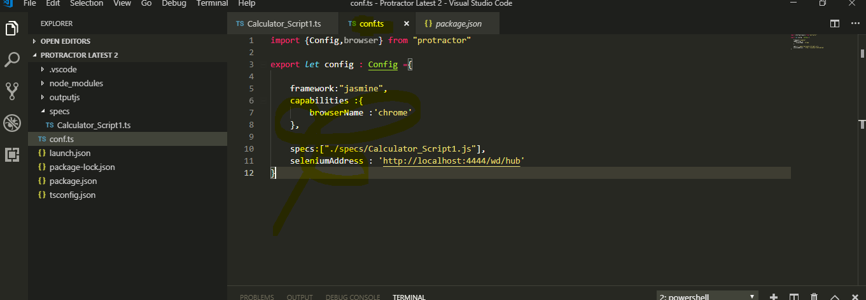

import {Config,browser} from "protractor"

export *let* config : Config ={

framework:"jasmine",

capabilities :{

browserName :'chrome'

},

specs:["./specs/Calculator_Script1.js"],

seleniumAddress : 'http://localhost:4444/wd/hub'

}

1. Script:

